$$classification-2$$

$$classification-1$$

$Linear regression=y=b_{o}+b_{1}*x_{1} j=\frac{1}{n}*sum{\left({(y}_{a}-y_{p}\right)}^{2})$

$Lasso regression :cost function==\frac{1}{n}*sum{\left({(y}_{a}-y_{p}\right)}^{2})+ lambda* slope$

$Ridge regression: cost function==\frac{1}{n}*sum{\left({(y}_{a}-y_{p}\right)}^{2})+ lambda*(slope)^2$

$Elastic regression:lasso and ridge alpha, l1$

$Logistic regression:sigmoid function$

$Decision Tree:Entropy and gini$

$Niave bayes:Multiplication , class condtional , lapalacian$

$KNN:Euclidian distance$

$$Metrics$$

$$MSE RMSE R_{Square}$$

$$Accuracy,cmt, precision, recall f1, roc-auc ,$$

$$Elbow method, silouthe score$$

$$Overfit-underfit-normalfit$$

$$Bias-variance$$

$$Whcih method when it become overfit$$

$$How to avoid overfit$$

$More data$

$Regularization$

$Data augmentation$

$$Feature selection methods$$

$VT$

$Mutual info classify$

$p-value$

$Foraward-Backward$

$VIF$

$$Ensemble method$$

$$Svm$$

$$Recommendation engine$$

$$PCA$$

$$Gradient descent====DL$$

$$23 and 24 Im on leave$$

$$25th deep learning$$

$$work shop Langchain basics (sunday)$$

$$Saturday===sql full day 9 to 5$$

$$Ensemble methods$$

$$Ensemble:Grouping or combine$$

$$Ensemble methods: combine the models$$

$$data why we want develop a different different models on entire data$$

$$why we can't develop different models on different parts of data$$

$$ML:$$

$$we divided data into two parts train and test$$

$$X_{train} , y_{train} is used to develop the ML model$$

$$DT is developed by using X_{train},y_{train}$$

$$LR is developed by using X_{train},y_{train}$$

$$KNN is developed by using X_{train},y_{train}$$

$$Compare the DT,LR,KNN===$$

$$Assume that we have a data has data=1000 obsevations$$

$$1000 observations divided into 4 parts$$

$$p-1:250 observations$$

$$p-2 :250$$

$$p-3:250$$

$$p-4:250$$

$$p-1 data is used to develop DT algorithm$$

$$p-2 data is used to develop knn alg$$

$$p-3 data is used to develop LR$$

$$p-4 data is used to develop NB$$

$$a new test sample pass to the DT,LR,NB,KNN$$

$$out of 4 predictions , the majority one is the final one$$

$$if it is numerical take the average of 4 predictions$$

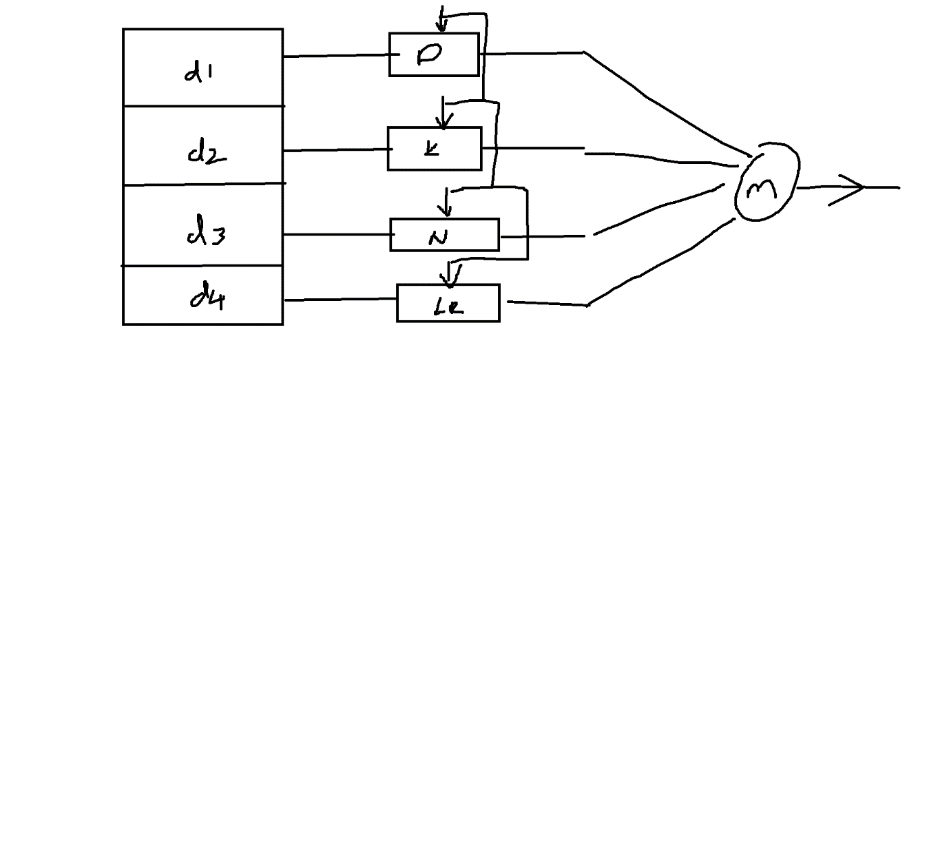

why we need take avg predict value each model ?

Average accuracy

For the numerical data ==== we cant deni

All the models are important , every model is trained on different part of the data

Traing the different models on same data ==== best one

$$Ensemeble methods are divided into two parts$$

$Bagging$

$Boosting$

$$Bagging:$$

$Bagging is a part of ensemble method$

$combination of different models on different parts of data$

$How to divide the data?$

$which models you need to choose?$

$Bagging: B+Agging:Bootstrap aggregation$

$Bootstrap aggregation is a method to pick the data$

$Random with replacement$

$If you do this methods , every time you will get$

$$63\% of data we can pick$$

$37\% of data never selected$

$assume that there are 100 values are there$

$if you do Bootstrap aggregation$

$63 values can choose, 37 values never choose$

$this 37\% of data is called Out of Bag\left(OOB\right)data$

$This 37\% of data connsider as test data$

$Because this data never part of the training$

$so 63\% data is used as training$

$37\% data is used as testing , OOB data$

$once you develop the model$

$train error and test error$

$test error is called as OOB error$

$$The best example for Bagging methods is$$

$$Random Forest:$$

$In random forest will choose the data by Bootstrap aggrgation$

$we know ensemble means combining of multiple models$

$In Random forest multiple models means:Decison trees$

$Combining of Multiple decsison trees :Random Forest$

$In Random forest we not only select the obseravtions randomly$

$$but also we select the features , to avoid the overfit$$

$$age gender income cr ms$$

$$These 5 columns are used to DT: root node: Income$$

$$age gender income cr ms$$

$$for second DT :Root node : inome$$

$$10 DT===== > inome$$

$$There is a chance to get same root node$$

$$The decison become biased$$

$$To avoid this select features also randomly for every DT$$

$$First DT : out of 5 fetaures we are slecting 3 randomly$$

$$Second DT: out of 5 features we are selcting 3$$

$$100 DT:$$

$$to slect the feature=\sqrt{predictors}$$

$$assume that data has 100 columns$$

$$\sqrt{100}=10 features$$